Session 1
Task 2:
Create a new database called InstaClone in MySQL Workbench, then create a table named Users with columns: user_id (INT, primary key), username (VARCHAR), email (VARCHAR), and followers_count (INT)

Query: create table users(user_id primary key, username varchar(100), email varchar(40), followers_count int;
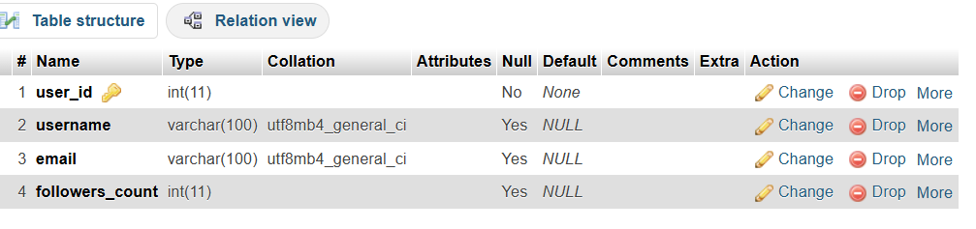
Task 3:
Insert 3 sample users into the Users table you created, using realistic Instagram-style usernames and follower counts.

Query: INSERT INTO Users (user_id, username, email, followers_count) VALUES
(1, 'travel_with_riya', 'riya.sharma@gmail.com', 15420),
(2, 'aarav.fitness', 'aarav.mehta@gmail.com', 8730),
(3, 'foodie_priya', 'priya.nair@gmail.com', 23150);
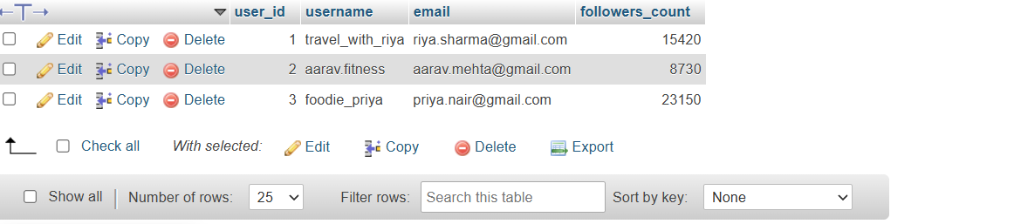

Task 4 :
Create another table in the InstaClone database called Posts with columns: post_id (INT, primary key), user_id (INT), caption (VARCHAR), and post_date (DATE). Add a foreign key from Posts.user_id to Users.user_id to establish a relationship.
Query
CREATE TABLE Posts (
post_id INT PRIMARY KEY,
user_id INT,
caption VARCHAR(255),
post_date DATE,
FOREIGN KEY (user_id) REFERENCES Users(user_id)
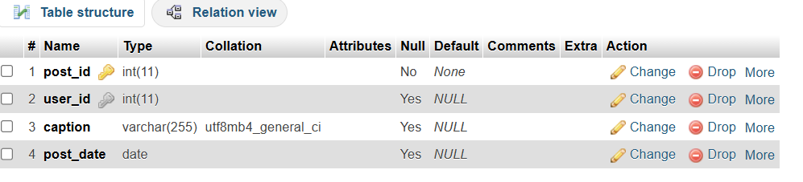
Task 5:

Write a short comparison (3-4 lines each) of MySQL, PostgreSQL, Oracle, and SQLite, focusing on where each one is commonly used (for example: web apps, mobile apps, enterprise systems, etc.).
Ans
Task 5: Comparison of Database Management Systems
1. MySQL: MySQL is an open-source relational database management system. It is commonly used for websites and web applications.
2. PostgreSQL: PostgreSQL is an open-source relational database known for advanced features and handling complex queries. It is used in large applications and data analysis.
3. Oracle Database: Oracle is an enterprise-level database used by large companies for banking, business applications, and managing large amounts of data.
4. SQLite: SQLite is a lightweight database that stores data in a single file. It is commonly used in mobile applications and small software projects.
Conclusion
MySQL is useful for web development, PostgreSQL supports advanced database operations, Oracle is suitable for enterprise applications, and SQLite is ideal for lightweight applications.

